Leaflet for Parents and carers
GP annual health checks for children and young adults with learning disabilities
(Intellectual disabilities)


What do we know already?
Children with Learning Disabilities are just like any other children and can get all the usual childhood illnesses and infections. However, they can be very difficult to identify if it is the first time the GP has seen the child or young person.
If a child is known to a paediatrician, it can be tempting for the parent carer to go straight to the specialist support throughout their childhood and not make any contact with their GP.
However, when the child becomes 18, this specialist support will cease, and the care is handed over to the GP.

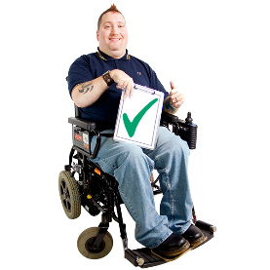

It is so very important to build a relationship with the GP from an early age. It is particularly important when the child is approaching transition to adulthood especially if the GP does not know the young person.

The Annual Health Check is an ideal opportunity for the GP to become involved in your child’s care. Annual Health Checks are available to young people with a learning disability aged 14 and over.

This also means that any reasonable adjustments that need to be made can be identified early and put in place for each appointment at the Practice.

What are reasonable adjustments?
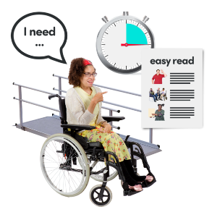
Reasonable adjustments are changes people must make so that someone with a disability can use or access something just as easily as everybody else. This is even more important in Health and Social Care Services.

Some examples of what a ‘reasonable adjustment’ might be are:
• making sure there is wheelchair access, having a ‘quiet’ waiting room
• providing easy read appointment letters
• giving priority appointments or first appointments
• longer appointments if more time is needed, home visits if attending the surgery causes distress
• communicating / making arrangements directly with the parent or carer (consider consent/best interest)

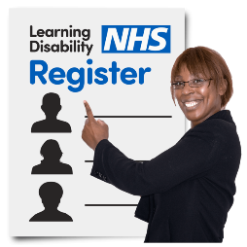
GP Learning Disability Registers

GP learning disability registers are a record of all the people registered with the practice that have a learning disability. This is different to the Register of Disabled Children that all local authorities are required to keep.
The GP learning disability register enables practice staff to identify children, young people and their families who may need extra help or support to access healthcare. Anyone with a learning disability can ask to go on it.

The benefits of being on the Learning Disability Register include:
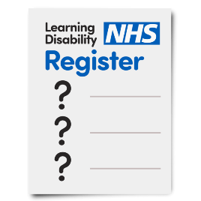
- having an annual health check, if 14 or over
- parent carers and siblings being identified as carers
- a better understanding of a child or young person’s needs before they attend health care settings
- improved transition to adult services, as your GP will be aware of your young person’s needs and can be involved in any planning.

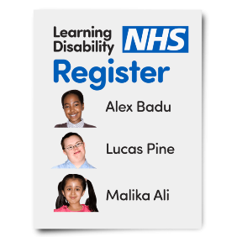
How do I put my child on the register?
A first step would be to have a conversation with your GP to discuss whether your child or young person has a learning disability or whether there are other additional needs or diagnoses that need highlighting.

The official definition of learning disability is someone who has all of the following:
• a significantly reduced ability to understand new or complex information, to learn new skills (impaired intelligence), with
• a reduced ability to cope independently (impaired
social functioning)
• which started before adulthood (under the age of 18), with a lasting effect on development.

Benefits of having an annual health check:
- The child or young person can build their confidence of going to the surgery, and their familiarity with practice staff.
- Identification of any previously undetected health needs or health conditions.
- Health needs are acted upon, for example, referrals to other health care practitioners are made.
- GP’s and practice staff can get to know the person better when they are well.

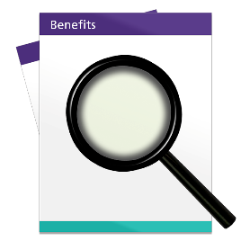

- Development of a Health Check Action Plan – see below.
- Can link to the duty on local authorities to make sure all Education, Health and Care Plan reviews from Year 9 onwards include a focus on preparing for adulthood, this is the health outcome.
- Additional information can be added to the Summary Care Record which can ‘flag’ your child or young person’s needs or reasonable adjustments so that all healthcare professionals that care for them are aware.

What to expect before an annual health check?

You may be asked to prepare for your child or young person’s annual health check by filling in a questionnaire. This will give you the opportunity to highlight anything you
or your child or young person would like to discuss, or if
there might be any elements of the health check that they may find difficult or distressing. It also helps the GP to know as much information as possible prior to the appointment.

You can find examples of questionnaires and an annual health check checklist at:
: Easy read health information :: Hampshire and Isle of Wight NHS Foundation Trust

If you have any questions about preparing for annual health check, call the doctor’s surgery.
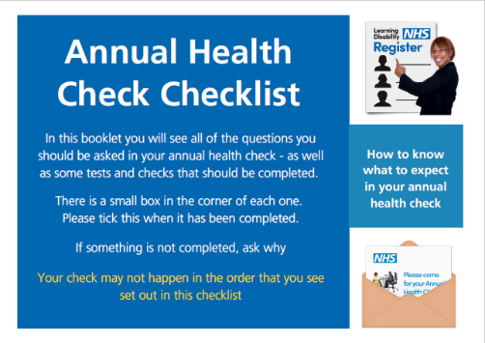

During the health check, the GP, practice nurse or other professional will:
• do a general physical check which may include weight, heart rate, blood pressure, taking blood and urine samples, examine abdomen
• ask about things that people with a learning disability often have problems with, such as epilepsy, constipation or problems with swallowing
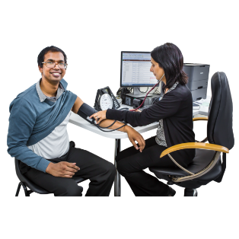

• review medicines
• check any existing health problems such as asthma or diabetes
• discuss any other health appointments (dental, optician, specialist appointments and more)
• ask about the support you are getting
• discuss transition planning
• discuss how to stay healthy and offer general healthy living advice where appropriate
• discuss and agree the Health Check Action Plan- please make sure you are given a copy.

• discuss transition planning
• discuss how to stay healthy and offer general healthy living advice where appropriate
(age dependant- ask about relationships/ contraception and/or cancer screening programmes)
• discuss and agree the Health Check Action Plan- please make sure you are given a copy.

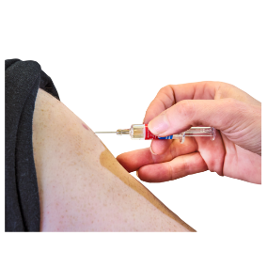
Flu vaccine
From September/ October your child or young person will be offered the flu vaccine. This is free.
Children are usually offered a nasal spray. However, adults with needle phobia can request nasal spray as a reasonable adjustment.

If there are any other immunisations that need to be discussed, please feel free to mention them.


Health Check Action Plans
Health Check Action Plans (HCAPs) are care plans that detail what is needed to keep your child or young person healthy. This should include actions by the GP, other health practitioners and can also include actions for you and your child or young person.

HCAPs should ideally be created and agreed with the child or young person as well as their family or carer, situation dependant.

Reviewed in August 2023

